

**Choosing the Right Coffee Machine in UAE**

In today’s fast-paced world, having the right coffee equipment can make all the difference for both businesses and coffee enthusiasts. A [**commercial coffee machine**](https://roballiespresso.com) is a must-have for cafes, restaurants, and offices, ensuring consistent quality and efficiency in every cup. From brewing large volumes of coffee to delivering café-style drinks, these machines are designed to meet high demands without compromising on taste. Whether you run a coffee shop or a workplace, investing in the right machine can elevate the overall experience for customers and employees alike.

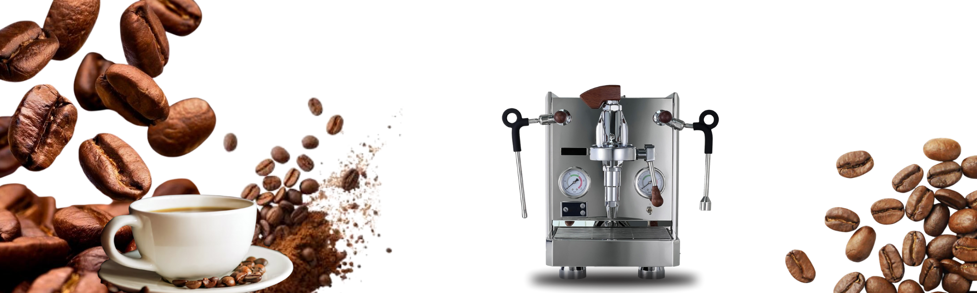

If you’re searching for a reliable **coffee machine in UAE**, there are plenty of options to suit different needs and budgets. Among them, the [**espresso coffee machine**](https://roballiespresso.com/product) remains one of the most popular choices, loved for its ability to craft rich, aromatic coffee with a professional touch. Whether it’s for a small setup or a large-scale business, choosing the right machine ensures not only better coffee but also long-term value. With the growing coffee culture in the UAE, finding the perfect coffee machine is easier than ever, making it possible to enjoy barista-style brews anytime.